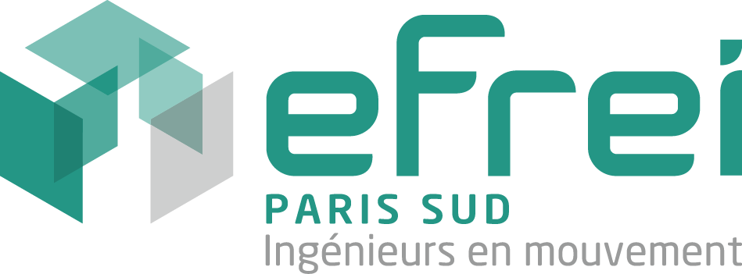 Degree-Seeking Students

APPLICATION FORM - ACADEMIC YEAR 2017/2018
Student’s Personal Data

last name:  first name: | Gender – F/M:
Date of birth (dd/mm/yy): | City of birth:  Country of birth:
Passport number:  Nationality:  Passport expiration date: | Tel:  Email:

Permanent address:

Name of person to be contacted in case of emergency:

Relation to student:

Phone number:

Email:

Postal Address:

Current Situation (2016-2017)

Are you currently registered as a student: Yes No

Are you currently employed: Yes No
Name of employer:  (If currently employed) | Type of Position:  (If currently employed)
Name of the university: | Field of study:
Degree sought: | Expected date of graduation:
Last degree obtained: | date:
Field of study: | Name of the institution:
Are you applying to another program in France or abroad?  Yes No | If yes, name of the institution:

Language Proficiency

Native Language:
Proficiency in English (for non-native speakers)  Written  - Beginner  - Intermediate  - Upper-intermediate  - Advanced  Oral  - Beginner  - Intermediate  - Upper-intermediate  - Advanced | Proficiency in French  Written  - Beginner  - Intermediate  - Upper-intermediate  - Advanced  Oral  - Beginner  - Intermediate  - Upper-intermediate  - Advanced
TOEIC / TOEFL/ IELTS scores: | TEF / TCF / DELF scores:
selection of a graduate major at efrei

MAJOR
Please check one major in the list below taking into accounts the language requirement*
french track (french b2 level required) | english track (english b2 level required)
information systems architectures and cloud computing  imaging & virtual reality  Security | business intelligence  it for finance  software engineering

Selection of Graduate Electives

Management IT Careers
Please check one Elective in the list below taking into accounts the language requirement*
french track (french b2 level required) | English track (English b2 level required)
Information Systems Architect  Consultant  Entrepreneur  Business Manager  Technical expert | International Project Manager  Innovation and Strategy

Areas of Activity
Please check one Elective in the list below taking into accounts the language requirement*
french track (french b2 level required) | English track (English b2 level required)
Energy  Banking and Finance  New Media and Video Games  Telecommunication and The Internet  Transportation of Tomorrow  E-Health | Sustainable Development

* Your choices are subject to Efrei’s admission committee’s approval. In case your choices are not validated, the admission committee may suggest alternative options.

-------------------------------------------------------------------------------------------------------------------------------------------------
A complete application must include the following:
- A certified copy of bachelor’s degree
- Certified copies of all university transcripts
- A statement of purpose describing your reasons for studying in France, for choosing Efrei, and describing your career objectives
- 1 letter of recommendation from a professor or a professional supervisor / career counselor
- A CV or resume in English
- Official TOEFL, TOEIC results or equivalent tests
- Official TEF, DELF scores or equivalent tests (only if applying for a program in French)
- 2 passport photos
- A copy of the relevant passport pages or copy of ID (for EU students)
- The Housing Application Form
- The Housing Agreement (2 full pages, signed and dated
- A signed and dated copy of the Computer User Agreement
- For non-European students: proof of a Medical and Repatriation Insurance policy in English covering the period in France from the day of arrival to the 1st of October. (At this date, all international students must subscribe to the French student health insurance plan.
**********************************************************************************************************
The completed application is to be sent by post no later than MAY 31st 2016 to:

Efrei, International Office,

30-32, avenue de la République,

94815 VILLEJUIF Cedex, FRANCE

